**Unit-1**

1. How many license plates can be made using either two letters followed by four digits or two digits followed byy four letters?
2. Determine the coefficient on x2y3z2 in the expansion of (x+y+ z)7.
3. For any positive integer n, the sum of squares of the first n positive integers is n(n+1)(2n+1)/6
4. Prove by first principle of mathematical induction.
5. How many integer valued solutions are there for the equation

X1+ X2+ X3+ X4+ X5 = 65 , all Xi >= 0

1. What is Sudok Puzzles ? Write its benefits For each n >0, prove that

$\left({n \atop 0}\right)$- $\left({n \atop 1}\right)$ + $\left({n \atop 2}\right)$- … +(-1)n = 0

1. A farmer buys 3 cows, 2 goats and 4 hens from a mar: who has 4 cows, 3 goats and 8 hens. How many choices does the farmer have?
2. Determine the coefficient on xyz in the expansion of (x + y + z)7
3. Prove that the sum of first n natural numbers is n(n+1)/2
4. Determine all integer solutions to the equation X₁+ X2+x3+X4 =7, where x>= 0 for all 1 <= I <=4
5. What is Sudoku puzzle? Explain the easiest way to solve Sudoku puzzle and write its three benefits.
6. For each n>0, prove that

$\left({n \atop 0}\right)$ + $\left({n \atop 1}\right)$ + $\left({n \atop 2}\right)$ +… + $\left({n \atop n}\right)$ = 2n

1. For the binary strings of length 10, how many of them
   1. Begins with 1
   2. Begins with 1 and ends with 0
2. Determine the coefficient of x2y2z2 in the expansion of (x+y+ z) 6.
3. For any positive integer n, the sum of the first n positive integers is n(n+1)/2 Prove by first principle of mathematical induction.
4. How many integer- valued solutions are there for the equation X1 +X2 + X3+ X4 + X5 = 72, all Xi >= 0
5. How Combinatorics is useful in graph theory?
6. For each n >0, prove that

$\left({n \atop 0}\right)$- $\left({n \atop 1}\right)$ + $\left({n \atop 2}\right)$- … +(-1)n = 0

**Unit-2**

1. Check whether the following graphs are isomorphic or not.

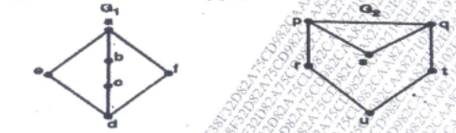

1. Verify Euler's formula for the graph connected graph

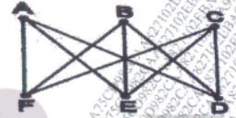

1. What is bipartite graph? Show Clcycle of sie vertices) is a bipartite graph
2. State Ramsey's theorem for graphs and also estimate Ramsey Numbers R(2.4) and R(3,5) R(2.4) and R(3,5)
3. Define adjacency matrix representation of a graph also draw the graph for the given adjacency matric
4. Give an example of graph which is both Eulerian and Hamiltonian and justify it
5. Explain colouring of graph and Chromatic numbers? Find the chromatic number of the given graph

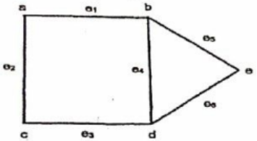

1. Define a regular graph. Draw a regular graph with five vertices
2. State and prove Ramsey's theorem.
3. Define adjacency matrix representation of a graph also draw the graph for the given adjacency matrix

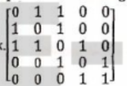

1. Define Euler's path, Euler's circuit and Euler's graph also find an Eulerian circuit in the given graph.

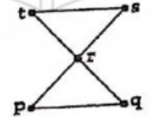

1. Explain isomorphism of graphs, Check whether the two graphs G1 and G2 are isomorphic or not.

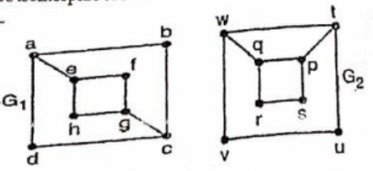

1. Show that following graphs are isomorphic.

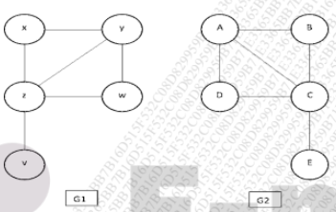

1. Draw a tree whose prufer(T)=6643143 with vertex set {1, 2, 3, 4, 5, 6, 7, 8, 9}
2. Explain the colouring of vertices in a graph.
3. State pigeon hole principle and Show that if any five numbers from the set {1,2,3,4,5,6, 7, 8} are chosen, then two of them will add up to 9.
4. Define adjacency matrix in a graph also find the adjacency matrix of the following graph.

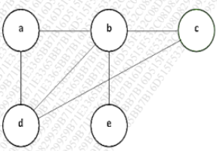

1. Give an example of graph which is both Eulerian and Hamiltonian and justify it.

**Unit-3**

1. Explain Polya's enumeration formula using chain index.
2. Explain Burnside's Lemma
3. Find maximum flow of the following network.

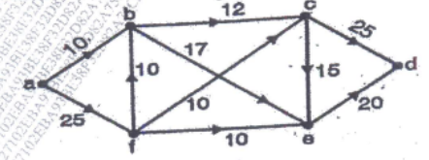

1. Define the capacity of cuts. Find the capacity of the cut (P.Q) where P=(a, b, g) and Q=(d, b, z)

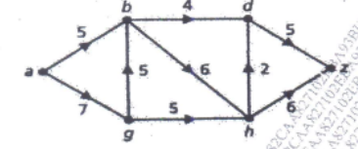

1. Write permutations shown below in cycle notation; compute (product of two permutations) and inverse of pi1



1. Explain a Complete matching with example.
2. Use Ford-Fulkerson algorithm to find the maximum flow for the following

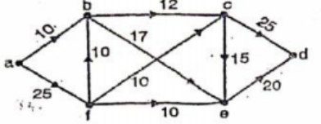

1. Define the capacity of cuts. Find the capacity of the cut (P.Q). where Pe(a, b) and Q (d, g, h, z)

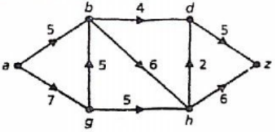

1. What is a complete matching? Explain with an example.
2. Write permutations shown below in cycle notation, compute $π1π2$ (product of two permutations) and inverse of



1. Suppose we are colouring the vertices of the square using black and white colour. Draw the colouring fixed by all possible transformations and explain it in brief.
2. What is the integer solution of linear programming problems?
3. Explain Matching in Bipartite graphs.
4. Explain Ford-Fulkerson's labelling algorithm.
5. Find maximum flow of the following network.

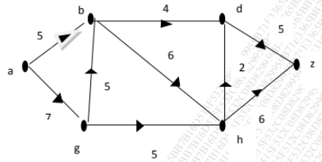

1. Suppose we are colouring the vertices of the square using black and white. Draw all the possible pattern of colouring also find the different transformations for fixed colouring
2. Write permutations shown below in cycle notation of 1 and2, also

compute 12 (product of two permutations)



1. State Burnside's theorem.

**Mix**

1. In how many ways we can arrange the letters in the word MATHEMATICS?
2. Find Chromatic number and Clique of the given graph

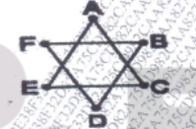

1. Explain the integer solutions of linear programming problems.
2. Determine the union and intersection of the graphs G, and G.

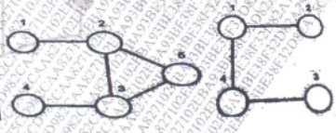

1. Draw all regular graphs on 4 vertices with degree two.
2. From a standard deck 52 cards. In how many ways we can draw three cards in succession without replacement?
3. Find minimum spanning tree of following graph using Kruskal's algorithm.

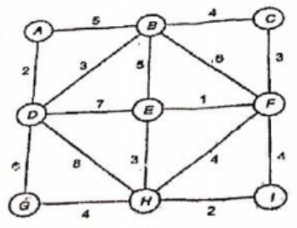

1. Explain polya’s enumeration formula
2. Explain Burnside's Lemuna
3. Expand (x+y) using binomial theorem and find the coefficient of xy.
4. In how many ways can we arrange the letters in TALLAHASSEE? How many of these arrangements have no adjacent A's?
5. Define Chromatic number with example.
6. Explain flows and cuts
7. Find the minimum spanning tree using Kruskal's algorithm for the given graph

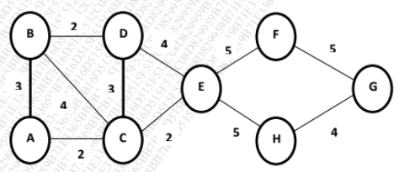

1. State first principle and second principle of mathematical induction